- Go to:
https://lamarcisd.rankonesport.com/Main/Default2.aspx?Type=4
- Click on Register Now! And create a new account.
- Check your email for your account activation email.
- Confirm your account and then log-in using the email address and password you just created.
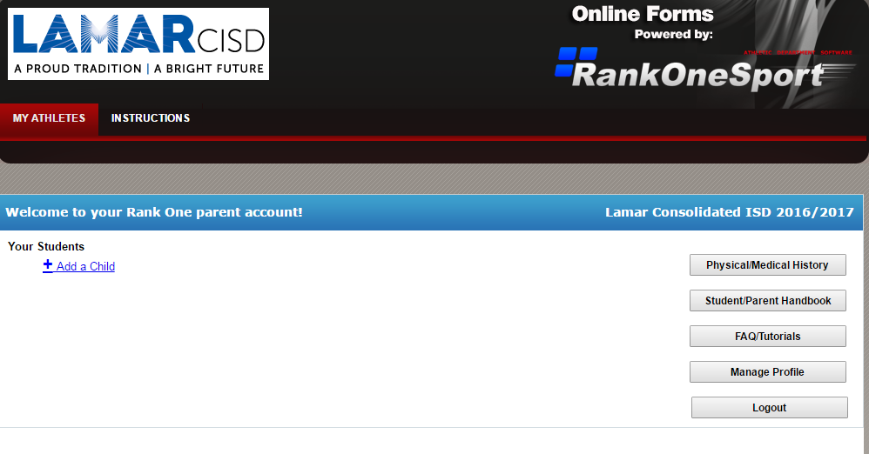
6.Then +Add a Child
5.Click on My Athletes
7. A pop-up box prompt you to fill out First Name, Last Name, and Date of Birth
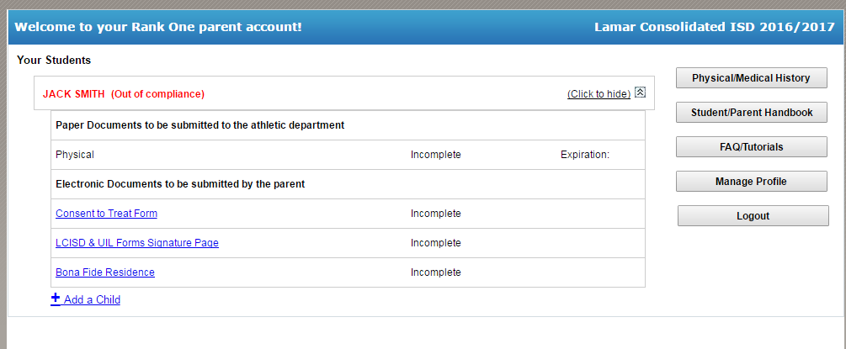
9. Click on each blue hyperlink to complete required forms
8. Click to view
10. Fill in required information on each page. At the bottom of each page:
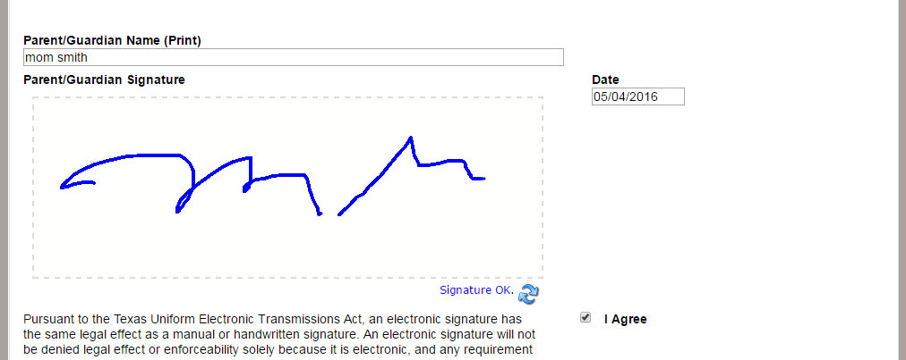
13. Check “I Agree”
12. Sign name
11. Type Name

14. When all forms are complete, the main page will say “Approved” or “Pending Approval”

